Practice 1.1 Report

Liang Yifan (Лян Ифань)

1, The Task:

Design a road, that will connect the points 1 and 2 (in fig.1) and transfer the load P=105kN (105000N).

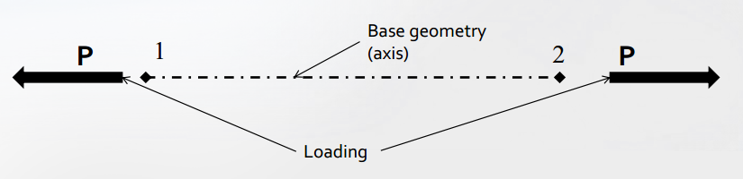

Fig. Force analysis of the task

In this task, only consider cross-sectional area and material as independent variables, ignore the other factors (such as the shape). So, use L-shape for all variants.

Geometry: The cross-section all along the rod is constant.

Loads: Pure tension load P leads to constant internal axial load N in the rod.

Requirements: no additional requirements.

Three material are allowable: Aluminum alloy D16T, Steel 30ХГСА and Titanium alloy ВТ20. Their ultimate tensile strength and density are as followed:

Table material parameters

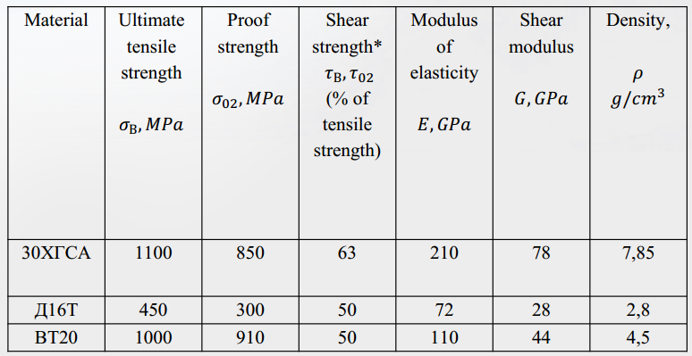

2, Stress analysis

In pure tension case applied stresses are:

$$σ=\frac{N}{F}$$

where F is the area of the section.

In this task N=105000N.

Assessment of the solution is based on safety factor and weight of the structure. The safety factor:

$$η=\frac{\left[σ\right]}{σ}$$

where $\left[σ\right]$ is the ultimate tensile stress.

The weight of the length unit:

$$G=ρ*F$$

When $η≈1.1$ it is optimum safety factor, $η<1.1$ is not satisfactory design, $η>1.1$ is overdesign. So the aim of the task is to find an appropriate group of material and shape such that the $η≈1.1$ and the weight is as small as possible.

3, Variants design

Using L-shape for all the variants. Firstly, design some L-shape cross section with different area. The shapes and geometry parameters are as followed:

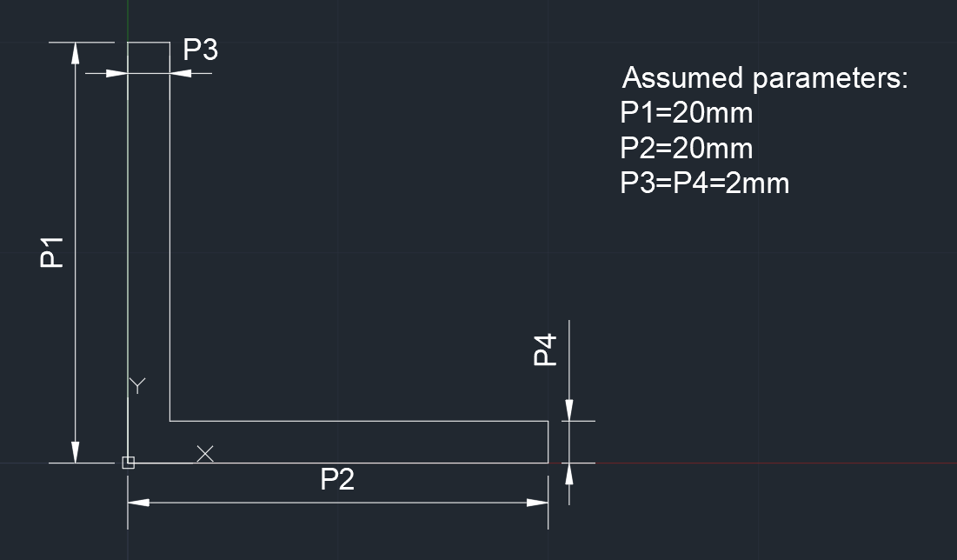

Fig. L-shape 1

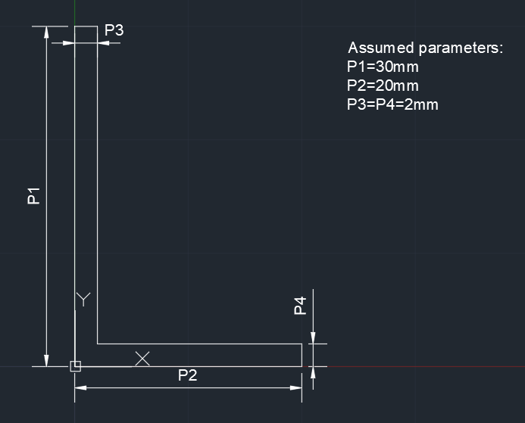

Fig. L-shape 2

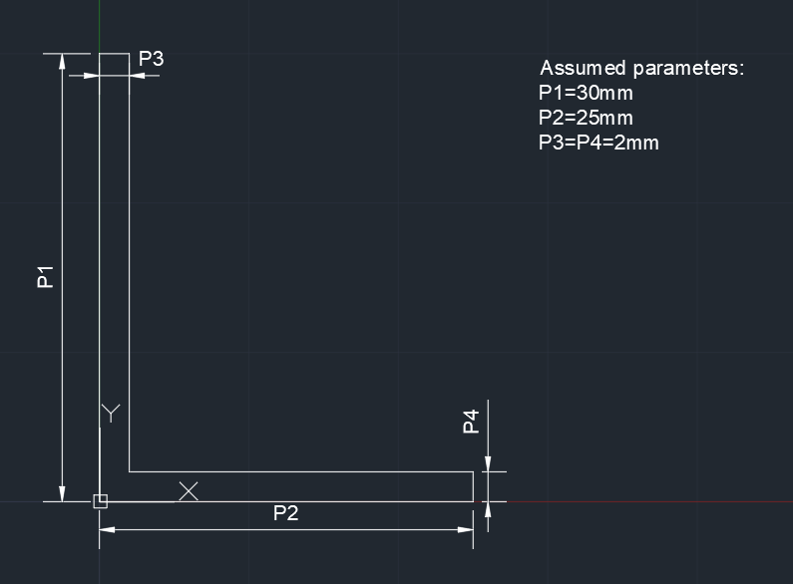

Fig. L-shape 3

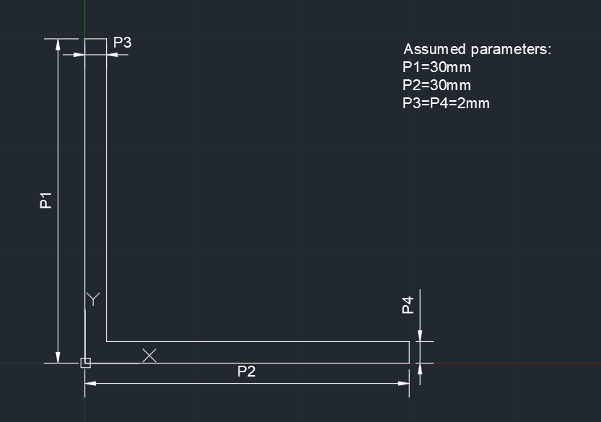

Fig. L-shape 4

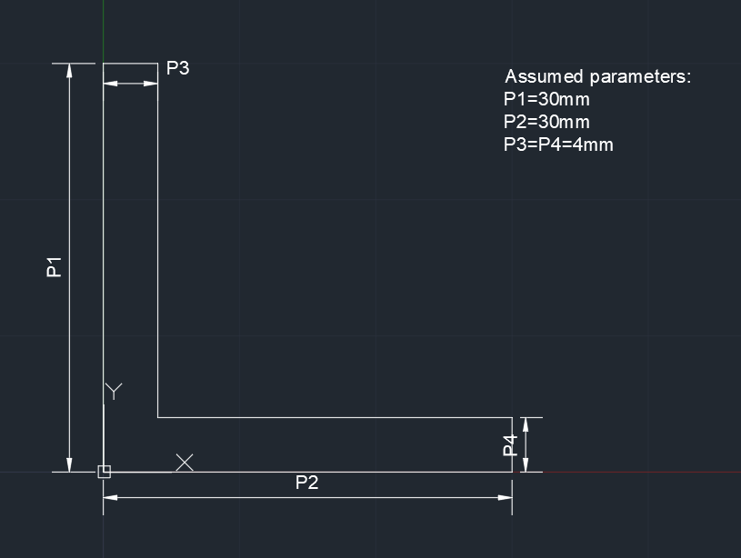

Fig. L-shape 5

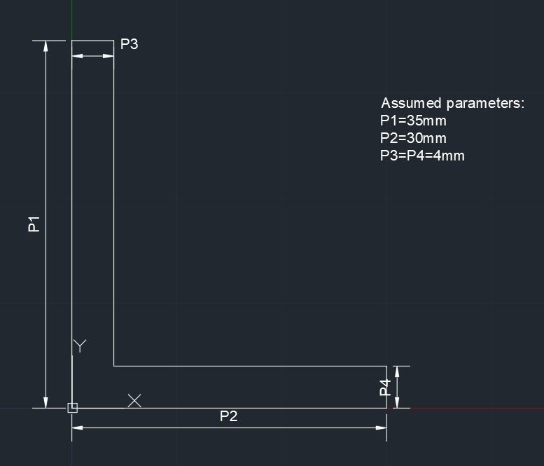

Fig. L-shape 6

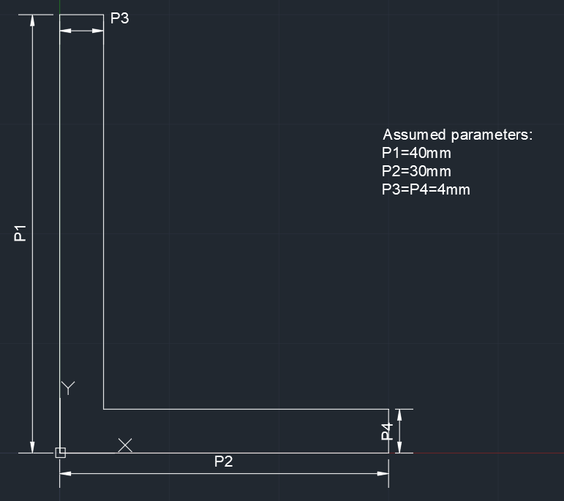

Fig. L-shape 7

Then arrange the variants with different materials and shapes. Calculate the cross-sectional area, safety factor and weight.

The results are as followed:

Table Results table



Through the table can find that the variant No.9 is the ideal case, with area 116 $mm^{2}$, safety factor 1.104762 and weight 0.522kg/m.

4, The optimum variant

As we get the ideal area by calculation, the next step is to find the standard variant, which is chosen after standard higher value of area F of the optimum section 116 $mm^{2}$. As it has a higher area, the safety factor would not be smaller than the former one.

Check the table of the standard variant:

Table Standard Variant Table



Through the table, can determine the final optimum variant and its geometry parameters.

Then draft the optimum section with dimensions:

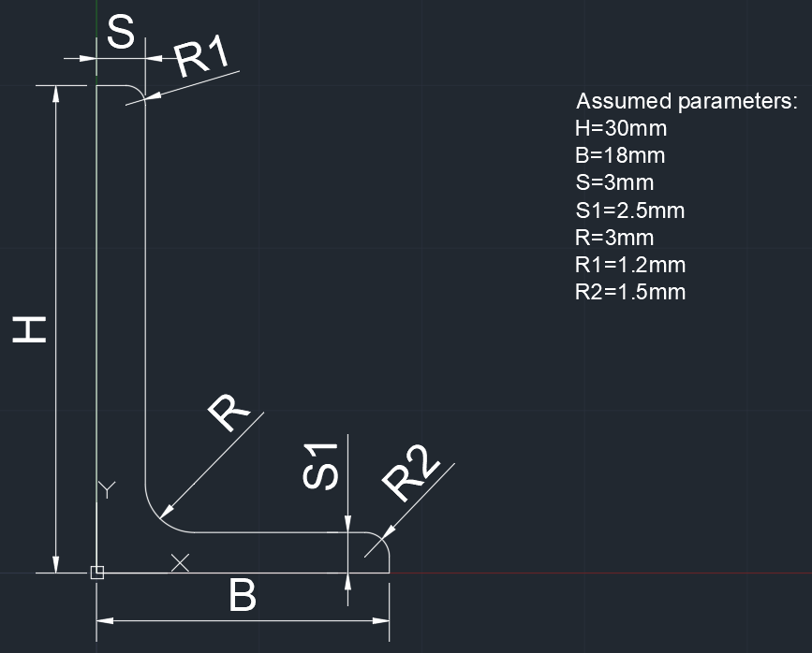

Fig. L-shape 8 (optimum)

And calculate the final safety factor and weight for the optimum variant:

Table The optimum variant



In the conclusion, the optimum variant is made with material Titanium alloy BT20, and its safety factor is 1.225138, its weight is 0.578878kg/m. Its shape is as the L-shape 8 shown in Fig.9.